 | 12.1.24 Editors - Geometry Nodes Editor - Header - Add Menu - Mesh
Table of content
Detailed table of content 1
Add menu - Mesh 6
Dual Mesh 6
Edge Paths to Curves 6
Edge Path to Selection 7
Extrude Mesh 7
Flip Faces 8
Mesh Boolean 9
Mesh to Curve 9
Mesh to Points 10
Mesh to Volume 11
Sample Nearest Surface 11
Sample UV Surface 12
Split Edges 13
Subdivide Mesh 13
Subdivision Surface 14
Triangulate 14
Scale Elements 16
Edge Angle 16
Edge Neighbours 17
Edge Vertices 17
Edges to Face Group 18
Face Area 18
Face Neighbours 18
Face Group Boundaries 18
Face is Planar 19
Mesh Island 19
Is Shade Smooth 19
Vertex Neighbors 20
Shortest Edge Path 20
Set Shade Smooth 20

Detailed table of content
Detailed table of content
Detailed table of content 1
Add menu - Mesh 6
Dual Mesh 6
Inputs 6
Mesh 6
Keep Boundaries 6
Outputs 6
Dual Mesh 6
Edge Paths to Curves 6
Inputs 6
Mesh 6
Start Vertices 6
Next Vertex Index 7
Outputs 7
Curves 7
Edge Path to Selection 7
Inputs 7
Start Vertices 7
Next Vertex Index 7
Outputs 7
Selection 7
Extrude Mesh 7
Inputs 7
Mesh 7
Selection 7
Offset 7
Offset Scale 7
Individual 8
Properties 8
Mode 8
Outputs 8
Mesh 8
Top 8
Side 8
Flip Faces 8
Inputs 8
Mesh 8
Selection 8
Outputs 8
Dual Mesh 8
Mesh Boolean 9
Inputs 9
Geometry 1, 2 9
Self Intersect 9
Hole Tolerant 9
Properties 9
Operation 9
Intersect 9
Union 9
Difference 9
Output 9
Geometry 9
Mesh to Curve 9
Inputs 9
Mesh 9
Selection 10
Outputs 10
Curve 10
Mesh to Points 10
Inputs 10
Mesh 10
Selection 10
Position 10
Radius 10
Properties 10
Mode 10
Outputs 10
Curve 10
Mesh to Volume 11
Inputs 11
Mesh 11
Density 11
Voxel Amount / Voxel Size 11
Exterior Bandwidth 11
Interior Bandwidth 11
Properties 11
Resolution 11
Outputs 11
Volume 11
Sample Nearest Surface 11
Inputs 11
Mesh 11
Value 11
Sample Position 12
Properties 12
Data Type 12
Outputs 12
Value 12
Sample UV Surface 12
Inputs 12
Mesh 12
Value 12
Source UV Map 12
Sample UV 12
Properties 12
Data Type 12
Outputs 13
Value 13
Is Valid 13
Split Edges 13
Inputs 13
Mesh 13
Selection 13
Outputs 13
Mesh 13
Subdivide Mesh 13
Inputs 13
Geometry 13
Level 13
Outputs 13
Geometry 13
Subdivision Surface 14
Inputs 14
Geometry 14
Level 14
Creases 14
Properties 14
UV Smooth 14
Boundary Smooth 14
Outputs 14
Geometry 14
Triangulate 14
Inputs 15
Geometry 15
Minimum Vertices 15
Properties 15
Quad Method 15
Beauty 15
Fixed 15
Fixed Alternate 15
Shortest Diagonal 15
Polygon Method 15
Beauty 15
Clip 15
Outputs 15
Geometry 15
Scale Elements 16
Inputs 16
Geometry 16
Selection 16
Scale 16
Center 16
Axis 16
Properties 16
Domain 16
Scale Mode 16
Outputs 16
Geometry 16
Edge Angle 16
Outputs 17
Unsigned Angle 17
Signed Angle 17
Edge Neighbours 17
Outputs 17
Face Count 17
Edge Vertices 17
Outputs 17
Vertex Index 1 17
Vertex Index 2 17
Position 1 17
Position 2 17
Edges to Face Group 18
Inuputs 18
Boundary Edges 18
Outputs 18
Face Group ID 18
Face Area 18
Outputs 18
Area 18
Face Neighbours 18
Outputs 18
Vertex Count 18
Face Count 18
Face Group Boundaries 18
Inputs 19
Face Set 19
Outputs 19
Boundary Edges 19
Face Count 19
Face is Planar 19
Inputs 19
Threshold 19
Outputs 19
Planar 19
Mesh Island 19
Outputs 19
Index 19
Is Shade Smooth 19
Outputs 20
Smooth 20
Vertex Neighbors 20
Outputs 20
Vertex Count 20
Face Count 20
Shortest Edge Path 20
Input 20
End Vertex 20
Edge Cost 20
Outputs 20
Next Vertex Index 20
Total Cost 20
Set Shade Smooth 20
Input 21
Geometry 21
Selection 21
Shade Smooth 21
Outputs 21
Geometry 21

Add menu - Mesh
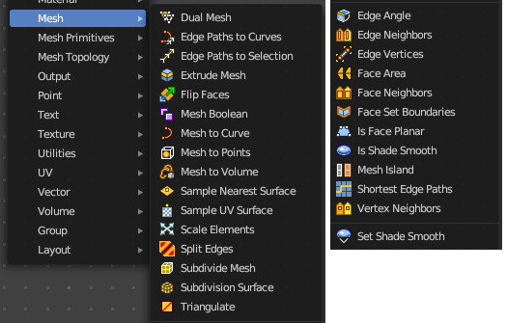
Nodes to modify the mesh geometry.

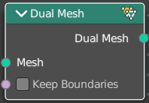
Dual Mesh
The Dual Mesh node calculates the dual of the input mesh. This means that faces get replaced with vertices and vertices with faces.

Inputs

Mesh
The input mesh.

Keep Boundaries
Keep the (non-manifold) boundaries of the mesh intact.

Outputs

Dual Mesh
The output mesh.

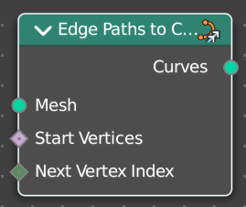
Edge Paths to Curves
Converts Edge Paths to Curves.

Inputs

Mesh
The input mesh.

Start Vertices
The start vertices of the edge path.

Next Vertex Index
The edge path by index.

Outputs

Curves
The output curve.

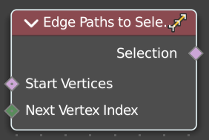
Edge Path to Selection
Calculates an edge path, and converts it to a selectoin

Inputs

Start Vertices
The start vertices of the edge path.

Next Vertex Index
The edge path by index.

Outputs

Selection
The selection

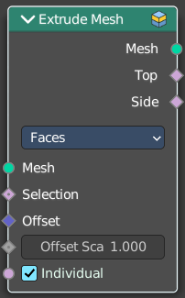
Extrude Mesh
Extrudes out geometry at the selection by a given amount.

Inputs

Mesh
The input mesh.

Selection
A selection of the mesh.

Offset
The offset amount.

Offset Scale
The offset scale. Without an offset this is equal the amount.

Individual
Just Faces mode. Extrude out individual faces.

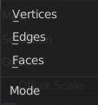
Properties

Mode
What kind of elements to extrude out. Vertices, Edges or Faces.

Outputs

Mesh
The output mesh.

Top
The top elements of the extrusion.

Side
The side elements of the extrusion.

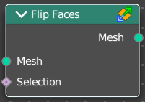
Flip Faces
Flips the winding order of the selected faces.
Blender developers decided not to call it Flip Normals. Since "normals are
derived data, changing them is only a side effect." However, what the node does is in fact to flip the normals.

Inputs

Mesh
The input mesh.

Selection
A selection of the input mesh.

Outputs

Dual Mesh
The output mesh.

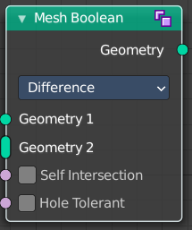
Mesh Boolean
The Boolean Node allows you to cut, subtract, and join the geometry of two inputs. This node offers the same operations as the Boolean modifier.

Inputs

Geometry 1, 2
Standard geometry input.

Self Intersect
Allow self intersection.

Hole Tolerant
Allow holes.

Properties

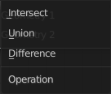
Operation
The boolean operation.

Intersect
Produce a new geometry containing only the volume inside of both geometry 1 and geometry 2.

Union
The two input pieces of geometry are joined, then any interior elements are removed.

Difference
Geometry 2 is subtracted from geometry 1 (everything outside of geometry 2 is kept).

Output

Geometry
Standard geometry output.

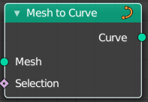
Mesh to Curve
Converts a mesh geometry to a curve geometry.

Inputs

Mesh
Input mesh.

Selection
A selection of the input mesh.

Outputs

Curve
Standard curve output.

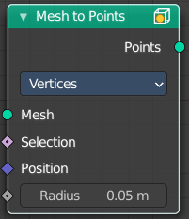
Mesh to Points
Converts a mesh geometry to a point geometry.

Inputs

Mesh
Input mesh.

Selection
A selection of the input mesh.

Position
The position of the points.

Radius
The radius of the points

Properties

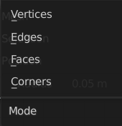
Mode
What geometry to convert to points.

Outputs

Curve
Standard curve output.

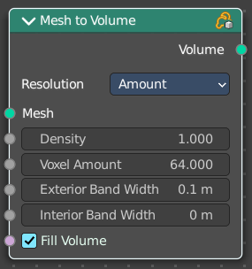
Mesh to Volume
Converts a mesh geometry to a Volume.

Inputs

Mesh
Input mesh.

Density
The density of the volume

Voxel Amount / Voxel Size
The voxel amount / the voxel size

Exterior Bandwidth
How much exterior bandwidth is calculated outside of the mesh. The larger the value the more unnecessary ray calculations happens.

Interior Bandwidth
Where to start the calculation inside of the volume.

Properties

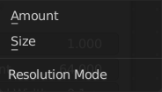
Resolution
How to calculate the volume. Based of the size or based at the amount.

Outputs

Volume
The volume output.

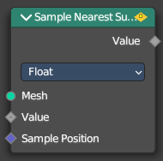
Sample Nearest Surface
Calculate the interpolated value of a mesh attribute on the closest point of its surface.

Inputs

Mesh
Input mesh.

Value
The value to calculate.

Sample Position
The sample position to calculate.

Properties

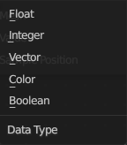
Data Type
Which data to calculate.

Outputs

Value
The output value.

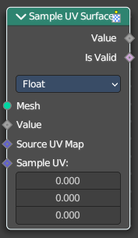
Sample UV Surface
Calculate the interpolated value of a mesh attribute at a UV coordinate.

Inputs

Mesh
Input mesh.

Value
The value to calculate.

Source UV Map
The input UV map.

Sample UV
The sample position to calculate.

Properties

Data Type
Which data to calculate.

Outputs

Value
The output value.

Is Valid
Wether the node could find a single face to sample at the uv coordinate.

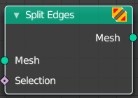
Split Edges
Splits the edges of the geometry.
Note that splitting edges breaks the mesh topology.

Inputs

Mesh
Input mesh.

Selection
A selection of the input mesh.

Outputs

Mesh
Standard Mesh output.

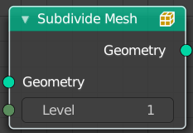
Subdivide Mesh
Subdivides the geometry by a simple division.

Inputs

Geometry
Standard geometry input.

Level
To which degree the geometry will be deformed.

Outputs

Geometry
Standard geometry output.

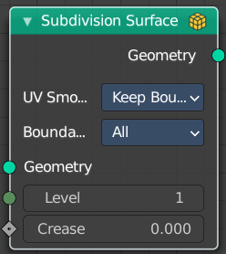
Subdivision Surface
The Subdivision Surface node subdivides the geometry using Catmull-Clark deformation.

Inputs

Geometry
Standard geometry input.

Level
To which degree the geometry will be deformed.

Creases
Control how smooth edges should be with Weighted Edge Creases.

Properties

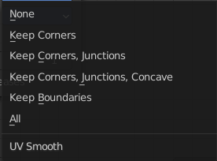
UV Smooth
The methbod to deal with smoothing the UV.

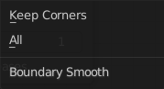
Boundary Smooth
Controls if open boundaries and corners are smooth.

Outputs

Geometry
Standard geometry output.

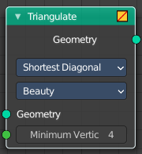
Triangulate
The Triangulate node triangulates all faces in a mesh.

Inputs

Geometry
Standard geometry input.

Minimum Vertices
Minimum number of vertices a face must have to be triangulated. For example, setting this value to 5, will prevent triangulation of Quads and only triangulate N-gons.

Properties

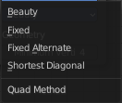
Quad Method
A quad is a polygon with four edges.

Beauty
Split the quads in nice triangles, slower method.

Fixed
Split the quads on their 1st and 3rd vertices.

Fixed Alternate
Split the quads on their 2nd and 4th vertices.

Shortest Diagonal
Split the quads based on the diagonal distance between their vertices.

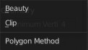
Polygon Method
Meant are N-Gons. Faces with more than four edges. Tris, Quads and N-Gons are all Polygons.

Beauty
Arrange the new triangles nicely, slower method.

Clip
Split the polygons using an ear-clipping algorithm (gives similar results to the tessellation used for the viewport rendering).

Outputs

Geometry
Standard geometry output.

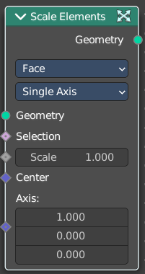
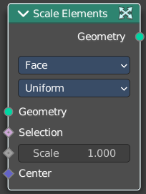
Scale Elements
Allows to scale the selected elements.

Inputs

Geometry
Standard geometry input.

Selection
A selection of the geometry.

Scale
The scale factor

Center
The center of the scaling.

Axis
Scale Mode Single axis only. Scale the selection separately along its single axis.

Properties

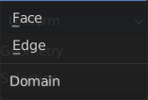
Domain
What kind of elements to scale.

Scale Mode
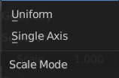
Uniform scales uniformly in all three world coordinates.
Single Axis scales separately in the single axis.

Outputs

Geometry
The output geometry.

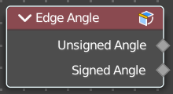
Edge Angle
Calculates the angle in radians between two faces that meet at an edge. Without two faces on the edge, the angle will be 0.

Outputs

Unsigned Angle
The unsigned output angle. The shortest angle will be picked.

Signed Angle
The signed angle between the two faces, where Convex angles are positive and Concave angles are negative. This calculation is slower than the unsigned angle.

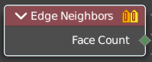
Edge Neighbours
Outputs the number of faces connected to each edge.

Outputs

Face Count
The number of faces.

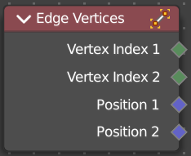
Edge Vertices
Outputs the index and position of the two vertices that defines an edge. Index outputs an integer. Position a vector.

Outputs

Vertex Index 1
The index of the first vertice.

Vertex Index 2
The index of the second vertice.

Position 1
The position of the first vertice.

Position 2
The position of the second vertice.

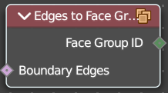
Edges to Face Group
Group Faces into regions, surrounded by the selected boundary edges.

Inuputs

Boundary Edges
The input edges.

Outputs

Face Group ID
The output face group.

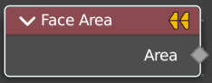
Face Area
Gives each face area a unique id. Which can be used in a capture attribute for example, to create instances of other geometry to this now unique face areas.

Outputs

Area
The face area output.

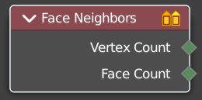
Face Neighbours
Outputs the number of vertices or faces connected to each face.

Outputs

Vertex Count
The vertex count for the face neighbors.

Face Count
The face count for the face neighbors.

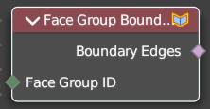
Face Group Boundaries
Find edges on the boundaries between face sets

Inputs

Face Set
The input face sets to calculate the boundaries from.

Outputs

Boundary Edges
The edges that lies on the boundaries between the different face sets

Face Count
The face count for the face neighbors.

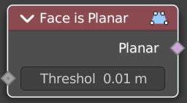
Face is Planar
Returns true if all of the points of the evaluated face are on the same plane.

Inputs

Threshold
The threshold to consinder the points to be at the same plane.

Outputs

Planar
True if the face is planar.

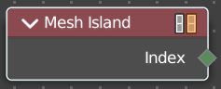
Mesh Island
Outputs a separate index for each mesh island. The indices are based on the order of the lowest-numbered vertex in each island.

Outputs

Index
The index output.

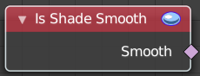
Is Shade Smooth
Retreives if the geometry is shaded smooth.

Outputs

Smooth
Smooth output.

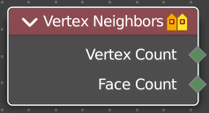
Vertex Neighbors
Outputs the number of vertices or faces connected to each vertex.

Outputs

Vertex Count
The vertex count for the vertex neighbors.

Face Count
The face count for the vertex neighbors.

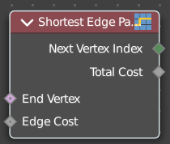
Shortest Edge Path
Calculates the shortest path from multiple start points.

Input

End Vertex
The last point of the path.

Edge Cost
The amount of calculation to find the shortest path.

Outputs

Next Vertex Index
The vertices index of the shortest path.

Total Cost
The calculation amount.

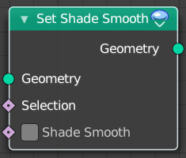
Set Shade Smooth
Retreives if the geometry is shaded smooth.

Input

Geometry
Input mesh.

Selection
A selection of the input mesh.

Shade Smooth
Set the shading to smooth.

Outputs

Geometry
Geometry output.

